Creating Precise Asset Layouts Using ProGrids:

ProGrids features an easy-to-use interface with configurable options. In this tutorial, you'll learn how to import Progrids.

Installing ProGrids

Step 1 -To start, install ProGrids from the Unity Package Manager.

Step 2- Go to the Window drop-down and click Package Manager.

Step 3- Ensure the drop-down in the top left of the window is set to All Packages.

Step 4. Select ProGrids from the list on the left side of the window.

Step 5. Click Install in the bottom right.

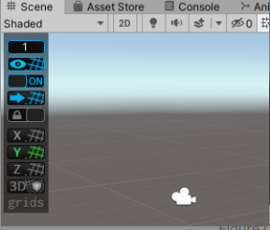

Step 6-Once you've installed ProGrids Click Tools > ProGrids> ProGrids Window. This will open the ProGrids overlay in the Scene window.

Step 7-Once you've opened ProGrids, you'll see a grid overlay in the Scene window. Your Scene will now have grids enabled and your GameObjects will automatically snap to the grid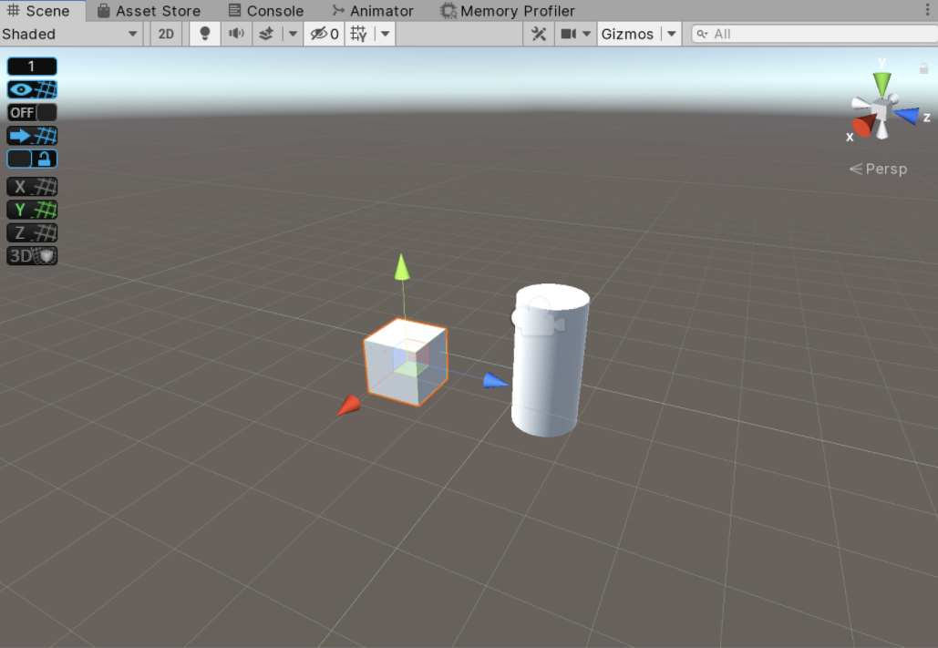

ProGrids Buttons

2. Button 2 toggles the display of the drawing of the grid guidelines in the active

Scene window.

This toggles the snap to grid functionality.

4. This snaps all selected objects to the grid.

5. This locks the center of the grid in perspective space

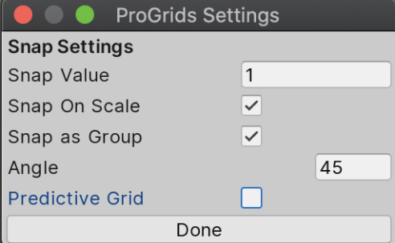

Conclusion:

With ProGrids, you can be confident that assets will line up properly. This allows you to focus on your Scene layout rather than spending countless hours trying to place assets manually.